Business Teachers’ Association of New York State and New York State Education Department present:
Business and Marketing Education
Department of the Year Award
Application 2017

School District Name: ________________________________________________________________________

School District Address: _____________________________________________________________________

High School Name: ___________________________________________________________________________

High School Address: ________________________________________________________________________

Contact Person for Department: ____________________________________________________________

Contact Person’s Email Address: ____________________________________________________________

Business Department’s Website Address: __________________________________________________

Business Department or School Phone Number: __________________________________________

Check Classification: (Based on number of high school students)
_____Class A – 525 and up
_____Class B – 305 – 524
_____Class C – 175 – 304
_____Class D – 0-174

Number of Certified Business Teachers in Department: __________________________________

Region Name: ___________________________

Long Island: Nassau and Suffolk
New York City: Bronx, Kings, New York, Queens and Richmond
Hudson: Duchess, Orange, Putnam, Rockland, Sullivan, Ulster and Westchester
Albany: Albany, Columbia, Greene, Rensselaer, Saratoga, Schenectady, Warren and Washington
North Country: Clinton, Essex, Franklin, Jefferson, Lewis and St. Lawrence
Central: Fulton, Hamilton, Herkimer, Montgomery, Oneida and Schoharie
Syracuse: Cayuga, Cortland, Madison, Onondaga and Oswego
Southern Tier: Broome, Chemung, Chenango, Delaware, Otsego, Schuyler, Steuben, Tioga and Tompkins
Rochester: Genesee, Livingston, Monroe, Ontario, Orleans, Seneca, Wayne, Wyoming, and Yates
Buffalo: Cattaraugus, Chautauqua, Erie, Niagara and Alleghany

Superintendent/Principal Signature: ____________________________________________________
Date: ___________________

Application due by May 15, 2017

Award Guidelines

One award for each classification will be given in each region of the State. The classifications are dependent on student enrollment. Previous winners may not apply in consecutive years.

Application must be postmarked by May 15, 2017 to:

Francine Martella
5 S. Landing Road
Rochester, NY 14610

Winners will be notified by June 30, 2017

Department Winners will be awarded at the
BTANYS Fall Conference 2017

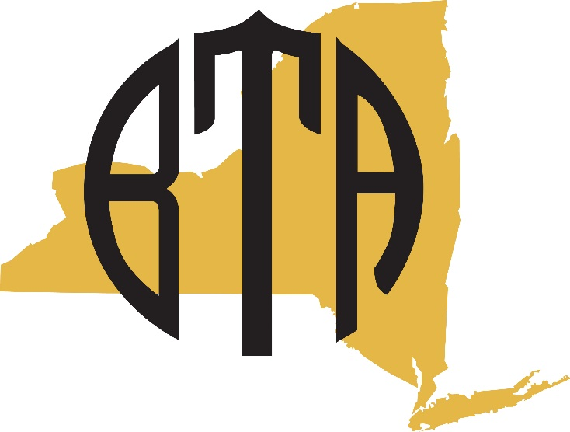

Application Information

Please respond to each of the following questions or statement that best describes the accomplishment of your department. All components need not be evident.

Required Information:
- Names and email addresses of all business/marketing teachers in the department including professional affiliations and involvement.
- List the total enrollment in each business/marketing course.

Evaluation Criteria:
- New courses - For the upcoming school year or implemented in the past 2 years. Provide course outline.

- CTE Endorsement- Describe program(s) and assessment(s). Attach proof of approval. Include specialized or equivalent courses used for Mathematics, Science, English or Social Studies credit.

- Advisory Board - List members w/affiliations and activities for the year.

- College credit - College, course names, number of students.

- Work-based Learning –List type and number of students in each.

- Student organizations or business clubs – Group name, number of students. Description if experiences are integrated into the curricula.

- Student achievements- Specific examples i.e. Business and Marketing Honor Society

- Public Relations –Description of efforts, samples and/or documentation.

- Professional development- Activities attended in the past 2 years.

- Administrator- Letter describing how the program positively impacts students and prepares them for college and career readiness.

Binders, folders, and other materials will not be returned. All items become the ownership of Business Teachers’ Association of New York State.
Business and Marketing Education
Regional Department of the Year
Scoring Rubric

School District: ______________________________ Region: ________ Classification: ______

 | Exemplary  evidence  3 | Satisfactory evidence  2 | Some evidence  1 | No evidence  0
New Courses Implemented/Planned
CTE Program Approval*
Advisory Board*
Specialized courses
College Credit
Work Based Learning
Student Organization
Student Recognition
Public Relations
Professional Development
Professional Organization and Involvement*
Letter from Administrator
*Weighted categories (2x)

Total Score: ________________

Committee Notes:

